Program to traverse or iterate ArrayList

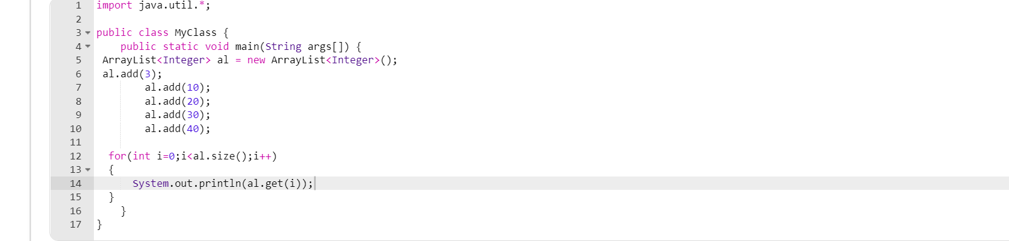

Output:

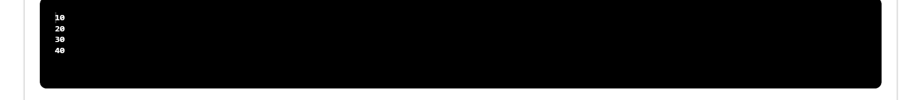

Program to convert List to Array

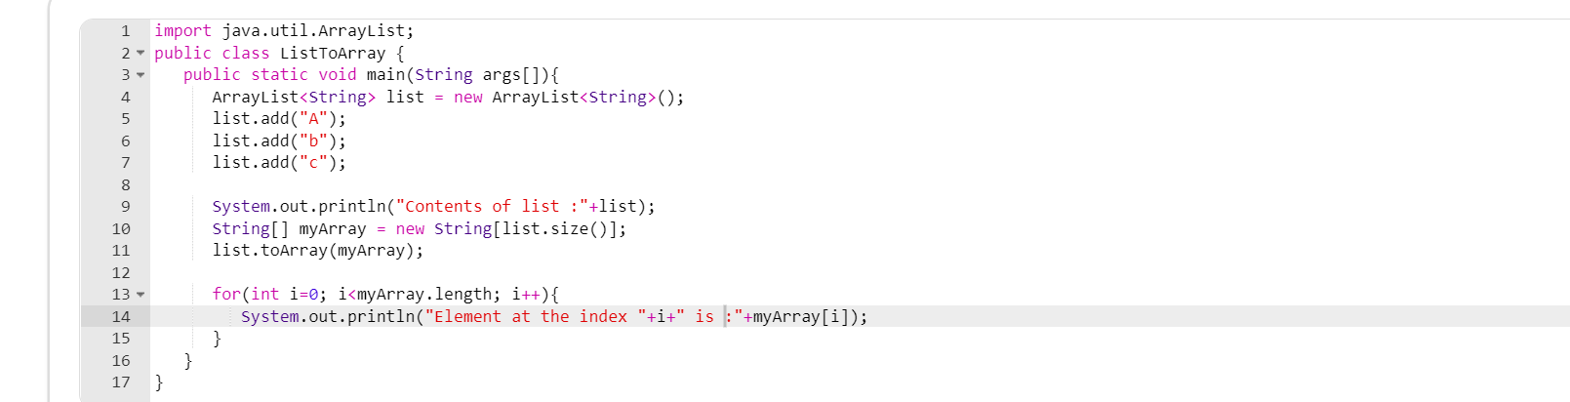

Output

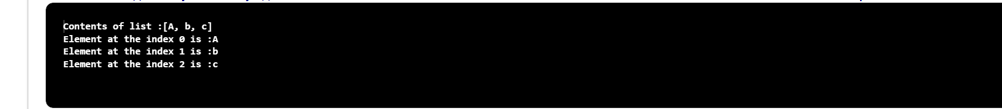

Program to check if element exist in ArrayList

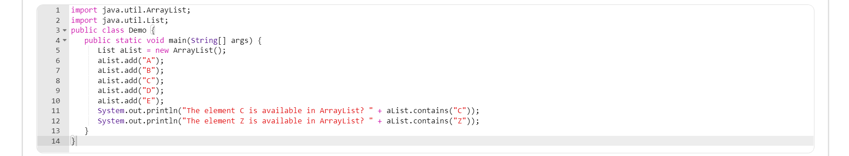

Output

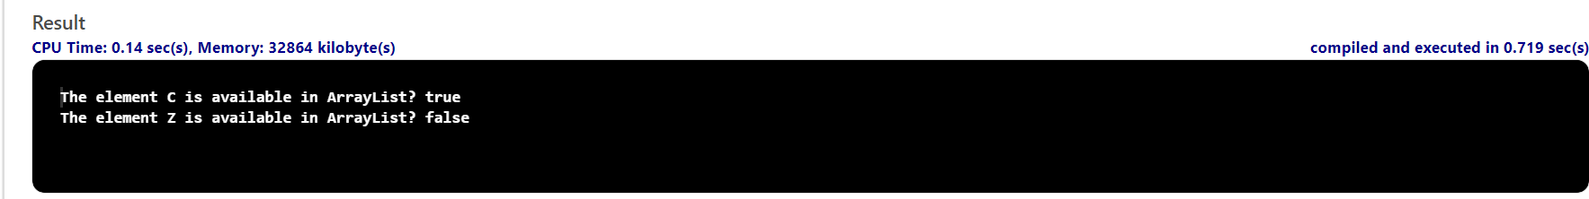

Given an element write a program to check if element exits in HashSet

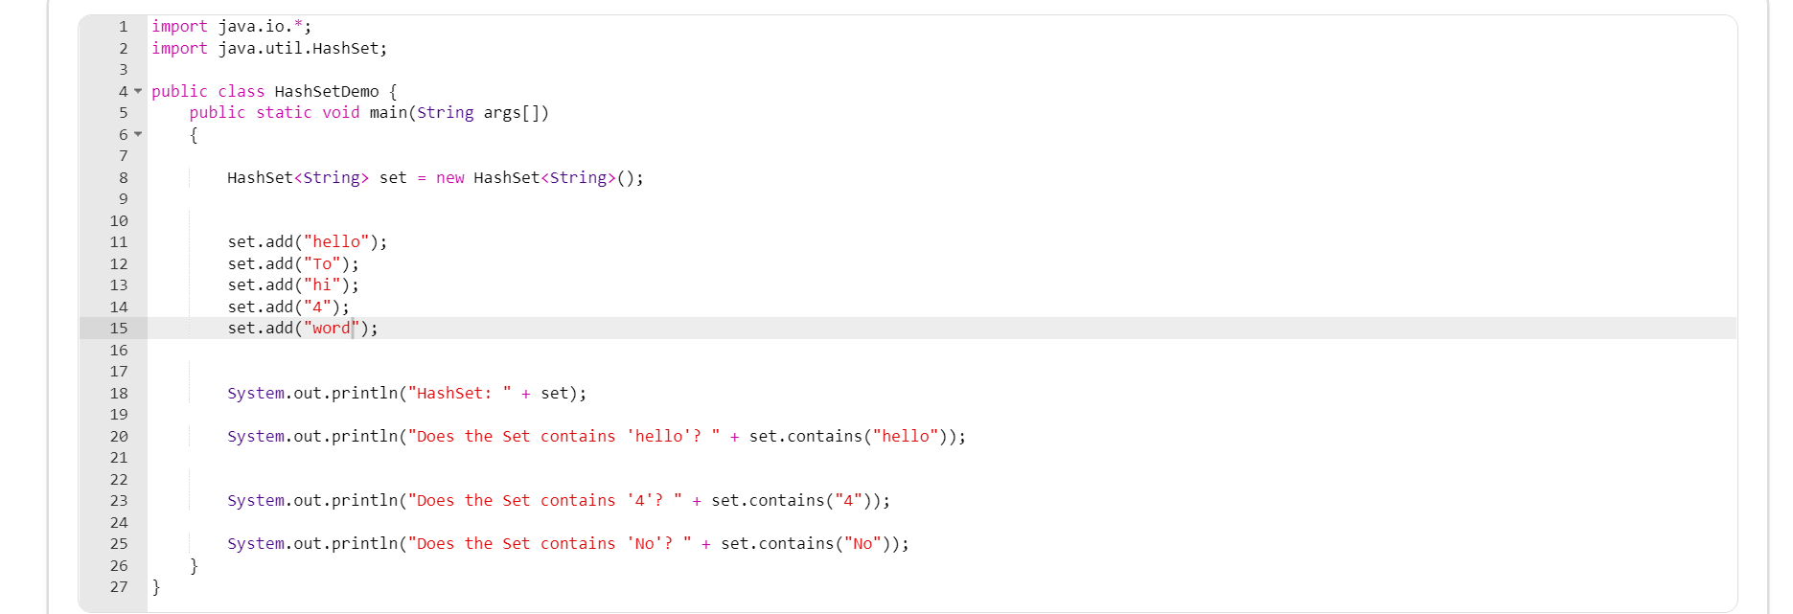

Output

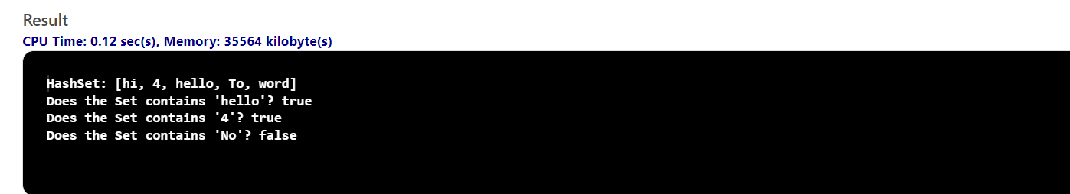h of ArrayList nt write a program to check if element exits in HashSet

Program to find the length of arraylist

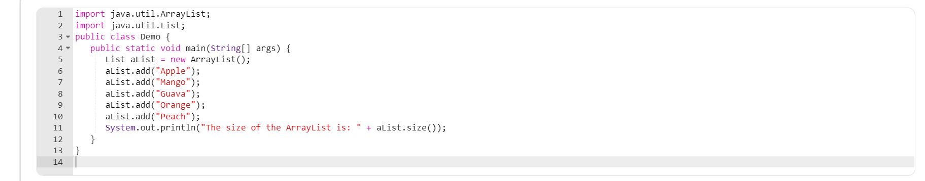

Output

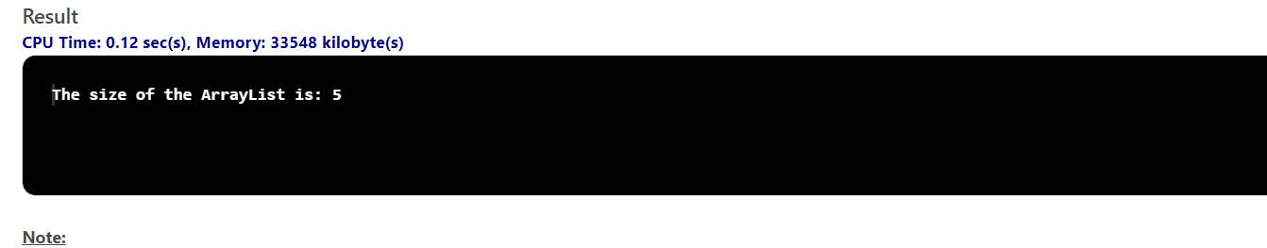

to check if element exists in Arrast